water behavior in ion exchange membranes on NMR data
^{1,2} Vitaly Volkov and Alexander ^{1,2}Chernyak
¹Institute of Problems of Chemical Physics RAS, 142432, Chernogolovka, Acad. N.N.Semenov av., 1, Russia,
²Science Center in Chernogolovka RAS, 142432, Chernogolovka, Lesnaya str, 9, Russia
E-mail: vitwolf@mail.ru ; sasha_cherniak@mail.ru
Introduction
Hydration processes control ionic transport in ion exchangers. For fuel cell application the membranes in possession of high water and ionic mobility at low humidity and temperature below 0ºC are very attractive. Perfluorinated sulfocation Nafion membrane is the more used and investigated among the rather wide ion exchange systems set. Our presentation devotes to reveal the interconnection of ionic channel structure, cation hydration, water and ionic translational mobility in ion exchangers. Nafion membrane is considered as a model system. For this goal attainment NMR spectroscopy is applied as the main technique for direct hydration ionic and water mobility in spatial scales from 10⁻¹⁰ to⁻⁴ m [1]. The brief reviewer and novel experimental results are presented. The special attention was paid to low water content and low temperature investigations of acid ionic form of Nafion membrane. Some details of this item have been given below.
Materials and methods
Extruded N117 (thickness127 μm, equivalent weight (EW) = 1100, Dupont, Ion Power Inc.) were used for the experimental characterization of Nafion in acidic (H⁺) ionic form. As-received membranes are pre-cleaned by boiling in 3 wt.% oxygen peroxide (H₂O₂) during 1 hour to eliminate organic residues. To guarantee a complete acidification and paramagnetic ion impurities extraction the samples are soaked in aqueous 10 M H₂SO₄ at room temperature during 1 hour and rinsed with demineralized water. Finally, the membranes are boiled 1 h in aqueous 1 M HCl and then rinsed with demineralized water. For the required humidity achievement Nafion samples were placed in open weighing bottle inserted in desiccators in which the relative humidity (RH) was controlled by saturated salt aqueous solutions. For NMR measurements the membrane plates with 3∙40 mm dimension were inserting in hermetic closed NMR sample tubes, which outer diameter was 5 mm. Dry membrane samples were got by drying at 120 º C till the constant weight or equilibration with P₂O₅ at room temperature. Water content λ is characterized as water molecule amounts per sulfonated group.
High resolution acid form of Nafion membrane ¹H spectra were recorded on the AVANCE-III -500 Bruker NMR spectrometer (proton Larmor frequency is 500 MHz) in the temperature region from -60 C to 30C. The ¹H chemical shift was calculated relatively bulk water ¹H NMR signal (4.3 ppm relatively TMS. The self-diffusion coefficients were measured on ¹Н nuclei by pulsed field gradient technique at the frequency 400.22 MHz. Measurements were carried out on Bruker Avance-III – 400 NMR spectrometer, equipped with the diff 60 gradient unit. Pulsed field gradient stimulated echo sequence was used. The gradient strength was varied linearly in 64 steps within a range from 0.1 to 27 T/m value. The integrated intensities of spectrum lines were used to obtain the dependence of echo signal attenuation on g² (diffusion decay) were analyzed in order to calculate self-diffusion coefficients.
Results and Discussion
Ionic Channel Nanostructure
Sulfonic acid groups counter ions and water molecules form nanochannels for ionic transport. Some structural models are discussed, [1,2], for example. The detailed Nafion perfluorinated sulfocation exchange membrane structure based on the small angle X-ray scattering, Mössbauer spectroscopy, ENDOR, NMR relaxation, self-diffusion and standard porosimetry data was constructed processes. It was concluded that macroscopic transfer through membrane is controlled by local ionic and water jumping between neighboring sulfonate groups, which frequencies, by-turn, are determined by cation hydration [1].

Hydration
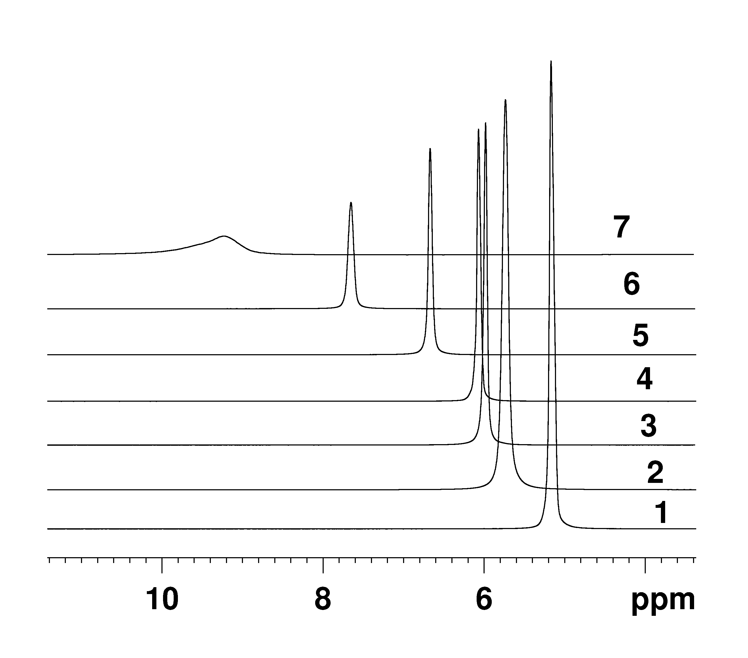
The H⁺ ionic form ¹H NMR spectrum is a singlet, which position is shifted in weak fields compare with bulk water signal. The NMR line is rather narrow that indicates on high proton mobility. The chemical shift value depends on water content and temperature (Fig. 1 and 2). From chemical shift water content and temperature dependences hydration numbers of hydrated H⁺ ion may be calculated. The correct hydration number calculation requires the knowledge of absolute water content value. Usually the water content is measured as the difference of weight between wet and dry membrane. In gravimetric technique the dry membrane is a membrane sample drying till the constant weight at temperature below the polymeric matrix decomposition temperature or on the dry P₂O₅. The absolute water content was determined directly by ¹H NMR spectroscopy technique and residual water content λ₀ = 1.9±0.4 water molecules per sulfonated group. Chemical shift humidity and temperature dependence analysis shows that in so called "dry" membrane hydroxonium ion H₅O₂⁺ is formed.
Figure 1 Evolution of water molecule ¹H NMR spectra during membrane humidity variation; 1- RH 95%; 2 - RH 78%; 3 - RH 64%; 4 - RH 58%; 5 - RH 33%; 6 - RH 10%; 7 - RH 0% (drying on P₂O₅ till constant ewight).
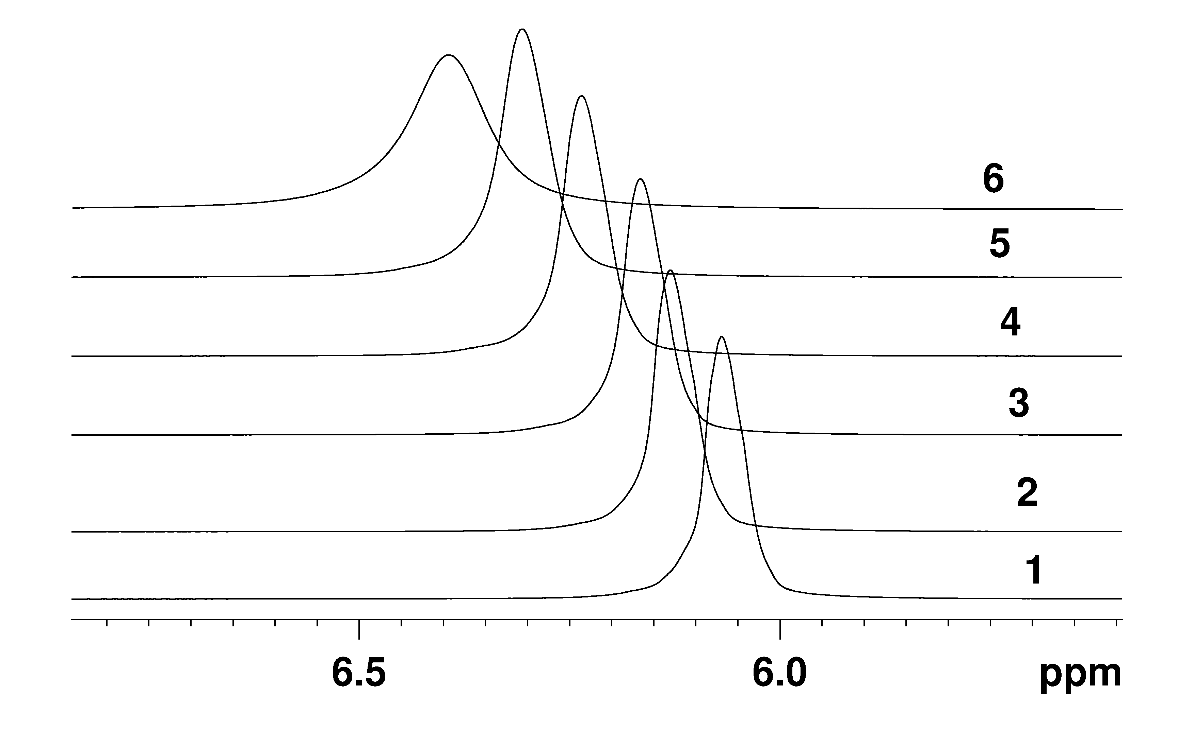
The stable H₅O₂⁺ hydroxonium cation formation is confirming by chemical shift temperature dependence analysis. It was shown that at low water content, till amount of water molecules per sulfonate group λ ≤ 4, H⁺ is coupled with two water molecules. For λ more than 6 H₉O₄⁺ hydrated cation is formed.
Water behavior at freezing temperatures
As it is shown in Fig. 2 water molecule mobility at temperatures below 0ºC is more high compare with ice.
The temperature dependence of mobile water molecules amount is shown in Fig.3. Water molecules are mobile even at -60ºC if λ ≤ 9, but anyway at low humidity DSC peak, which usually attribute to frozen water, is observed.
Figure 2. ¹H NMR spectra evolution during temperature variation in Nafion membranes at different water contents. Membrane samples were equilibrated with water vapor at 58% relative humidity. 1 - 25⁰С; 2- 10⁰С; 3 - 0⁰С; 4 - -20⁰С; 5 - -40⁰С; 6 - -60⁰С
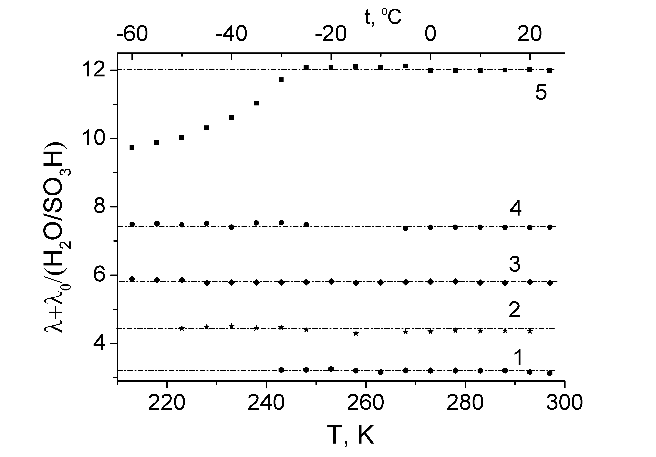
Figure 3. The dependences of mobile water molecule amount in Nafion membrane on temperature at different water content. 1 - λ = 3.2, 2 - λ = 4.4, 3 - λ = 5.8, 4 - λ = 7.4, 5 - λ = 12.
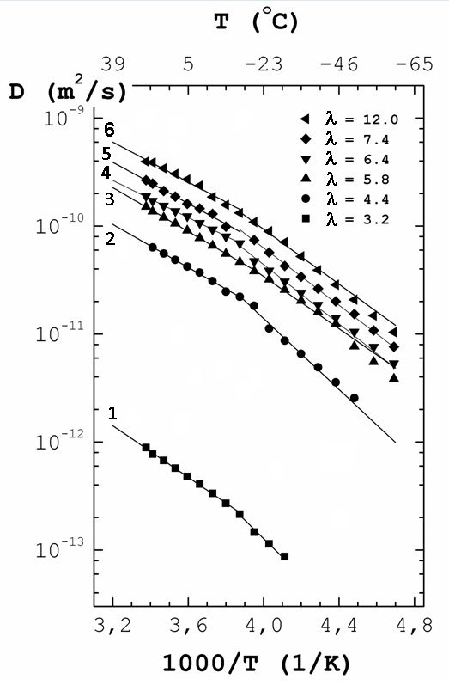
The detail explanation of this phenomenon is given in [3]. It was concluded that at temperatures below 0ºC water molecules form associates, which mobility is high. Associate self-diffusion activation energy in low temperature region is higher compare with the less associate water molecules in high temperature region. This is the reason of the slope increasing of self-diffusion coefficient temperature dependence (Fig. 4).

This work was supported by Russian Foundation for Basic Research (projects No. 18-08-00423 A).
References
- V.I. Volkov, A.A. Marinin. NMR methods for studying ion and molecular transport in polymer electrolytes // Russian Chemical Reviews 2013. V.82. p.248-272.
- N. Kononenko, V. Nikonenko, D. Grandeb, C. Larchet, L. Dammak, M. Fomenko, Yu. Volfkovich. Porous structure of ion exchange membranes investigated by various techniques // Advances in Colloid and Interface Science 2017. V.246. p.196–216
Figure 4 Water self-diffusion coefficient temperature dependences for Nafion membrane with different water content: curve 1- λ is 4, curve 2- λ is 5.1, curve 3- λ is 6.6, curve 4- λ is 7, curve 5- λ is 8.4, and curve 6- λ is 12.4.
- V.I. Volkov, S.L. Vasilyak, I.-W. Park, H.J. Kim, H. Ju, E.V. Volkov, S.H. Choh. Water behavior in perfluorinated ion-exchange membranes // Applied Magnetic Resonance 2003. V.25. p.43-53.

